SMALL HOLDER PALM OIL PROCESSING

A PROPOSAL
TO BUILD HUMAN CAPACITY AND UPGRADE A PROCESSING FACILITY TO CREATE EMPLOYMENT FOR MORE WOMEN

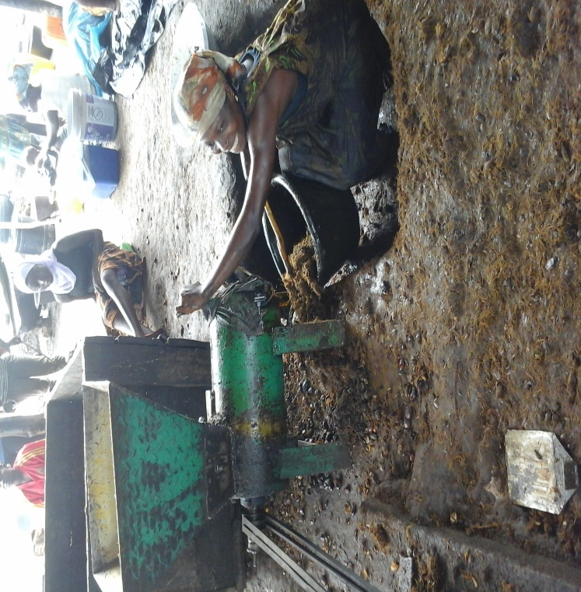

BY

JUNE 2015
1.0 INTRODUCTION
Juaben is a community in the Ejisu-Juaben Municipal in the Ashanti region of Ghana. It is about 44 kilometres away from the regional capital, Kumasi. Juaben and neighbouring towns have several acres of oil palm plantations which make palm oil processing is a lucrative business.
Ghana currently has a total of 305,758ha of oil palm. More than 80% of this is cultivated by private small-scale farmers (source: http://mofa.gov.gh/site/?page_id=8819). It is estimated that Ghana produces 243,852 tons of palm oil and has an unmet demand of 35,000 tons (http ://mofa.gov.gh/site/?page_id=8819).
In 2012, Gladys Ama Ampomah, a native of Juaben, started palm oil processing and named her processing facility “Y3 KOM M’AWURADE OIL MILLS”. Currently, the facility which is situated on a ½ acre land has a motorized digester, 2 screw presses, (6) six barrels and produces about 700 litres of palm oil daily, creating direct employment for forty (40) women.
There is a considerable amount of wastages and injury prone activities at the facility which need to be corrected.
An amount of GHC 34,988 (US$11,667) is being sought for human capacity building and equipment purchase to upgrade and expand the facility to employ more women.

2.0 PROBLEM STATEMENT
Y3 KOM M’AWURADE OIL MILLS has 40 female processors working separately. They work under a shed which provides sun shade for up to ten women at a time. Due to this limitation, the 40 women have to work in shifts. There is overcrowding when more than 10 women have to work at the same time to avoid fruit losses due to rots or to meet clients’ demands.
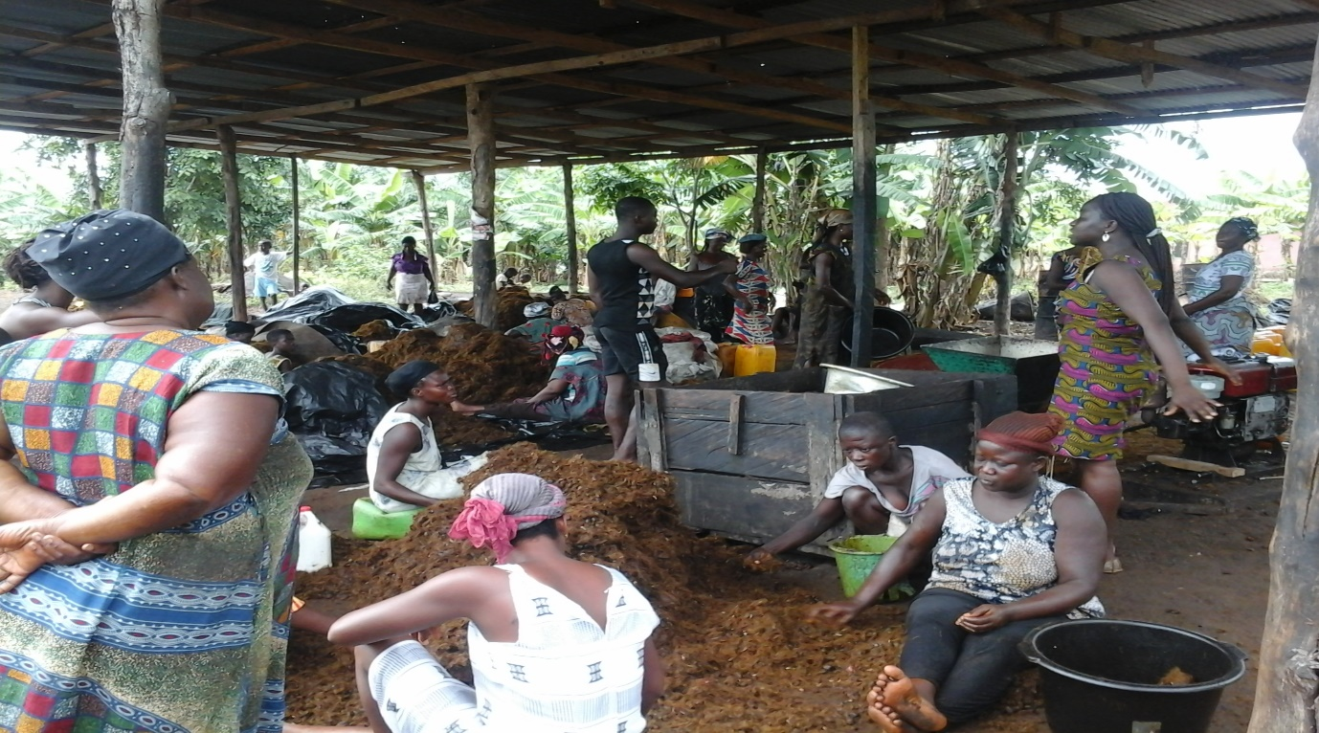
Women processing palm oil
Though, all the forty women use the same facility, there is lack of unity amongst them which has resulted in weak bargaining powers, a situation buyers capitalize on to take undue advantage.
Each woman is charged seven cedis (GHC 7) for every 200kg of fruits processed, which is paid on credit either with or in kind. The women, however complain of inadequate capital to purchase fruits in large quantities as a result of which they spend a bit more on transport, loading and off-loading. Their capitals range from one to five hundred cedis.
There are (6) six small and (1) one big barrels with a total capacity of 1,000 litres for cooking palm fruits. These barrels sit on seven stoves, which are scattered and pose danger to the processors as they meander their way through; stoking fire, adding water to boiling fruits, quenching fire, etc. Smoke from these stoves is not controlled and create conducive environment for smoke related ailments.
The stoves are in the open without protection from the weather and boiling of fruits cannot take place whenever it rains.
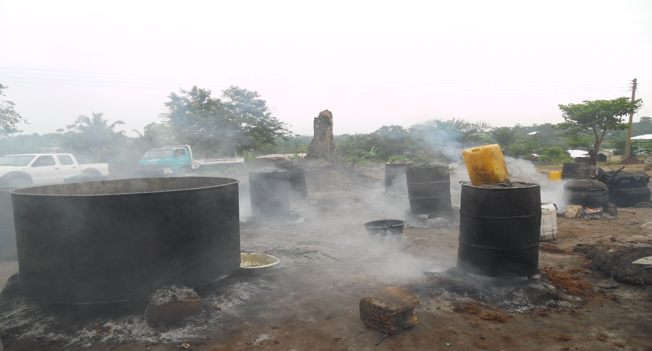
Stoves
The facility has one diesel-engine-powered digester with the capacity to digest ten tonnes of palm fruits per day. There are two 20-litre manual screw presses. The digester is under-utilized due to low capacity of the presses. Digested fruits cools off before pressing which hinders smooth flow of oil from the fibre thereby reducing the amount of oil extracted.
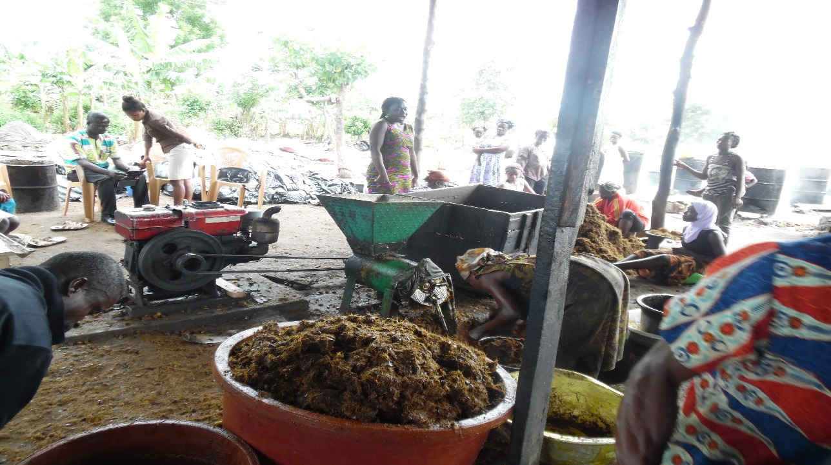
Digested fruits waiting to be pressed
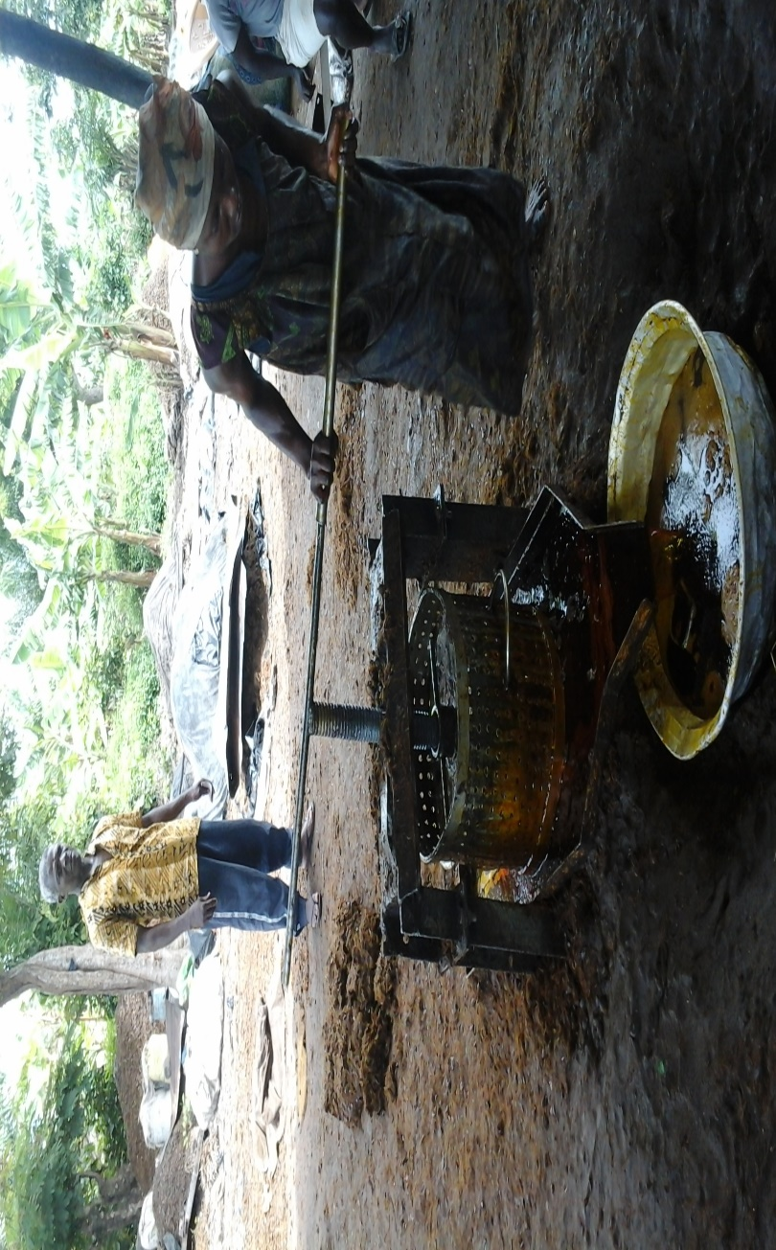
A processor pressing oil with one of the two presses
The facility has no winnower and as such much time is spent separating chaff from harvested palm fruits before boiling.
Oils produced are stored in 20-litre plastic containers and carried home for safe keeping as the facility has no storage facilities. The highly flammable nature of palm oil makes it unsafe for domestic storage, especially in large quantities.
There is a stockpile of palm nuts. These nuts may be processed into kernel oil to rake in additional income and the shell used as fuel. However, the processing facility lacks the needed kernel processing equipment and the nuts are sold at giveaway prices denying the women vital income.
There are no changing rooms for the women and therefore travel in and out of the facility in their oil soaked cloths, causing inconveniences on public transport.

3.0 PROPOSED INTERVENTIONS AND METHODOLOGIES
3.1 Group development training for processors
All forty women working at the facility shall be given group development training by Self-Help International. They shall be guided to mobilize themselves into smaller groups of between 3 and 6 and elect their leaders. This will ensure the formation of vibrant and cohesive groups that would withstand the test of time. There shall be four overall elected executives to supervise activities of the larger group.
This shall be followed with business and financial management training to enhance their skills in managing their businesses and finances.
3.2 Micro financing
The women shall be linked to Self-Help International micro finance scheme to enhance credit accessibility and management. Each woman shall receive a minimum of two hundred cedis (GHC 200) to be paid back in six equal monthly instalments.
3.3 Safety
Improved and well-arranged stoves shall be built for safer and easier boiling of fruits. This will help users to meander their way through; stoking fire, adding water, quenching fire, amongst others. It will also eliminate or reduce accidents. Smoke from newly built stoves will be minimal and controlled leading to reduced cases of smoke related sicknesses.
A shed shall be constructed over the stoves so that boiling can take place during rainy seasons.
3.4 Equipment
Two (2) additional barrels with a total capacity of 2,000 litres shall be procured and installed which will increase the number of cooking barrels to three. This will allow up to 3000 litres of palm fruits to be boiled at a time.
With the current digester capacity, two additional screw presses with a total capacity of at least 40 litres shall be procured. This will ensure that digested fruits are pressed faster.
A 100 litre capacity winnower to separate chaff from palm fruits before boiling shall be procured. Less time will be spent separating chaff from fruits and the labour cost of winnowing will reduce.
A milling machine for processing palm kernel shall be procured and installed. The miller will be run by the same engine/motor as the digester. This will minimize idle hours of the engine/motor and conserve space.
A 15hp 3-phase induction motor to run the digester and miller shall be installed. This will be powered by electricity. Installing a motor will allow the facility to have a dual power sources; electricity and diesel.
3.5 Storage and changing rooms
A storage room shall be constructed behind the main shed to safe keep processed oil and tools. Oils produced and stored in plastic containers will no longer be carried home for safe keeping. In addition a 2,000l storage tank shall be installed to reduce the number of plastic containers. The processors’ ability to store the oil in large quantities safely will also give them control over pricing and increase their returns.
A cubicle with lockers shall be provided, attached to the storage facility for the processors to change their cloths and keep valuable items.
3.6 Power supply
The facility shall be connected to the main power supply creating an opportunity for it to run on both diesel and electricity. Currently electricity is cheaper and by this arrangement the operational cost will reduce anytime electricity is available.

4.0 TIMELINES
 |  | Time (months)
 | Activity | M1 | M2 | M3 | M4 | M5 | M6 | M7 | M8 | M9 | M10 | M11 | M12 | Total
1 | Group development training |  |  |  |  |  |  |  |  |  |  |  |  | 6
2 | Stoves re-arrangement |  |  |  |  |  |  |  |  |  |  |  |  | 0.5
3 | Stoves shed construction |  |  |  |  |  |  |  |  |  |  |  |  | 0.3
4 | Equipment purchase and installation |  |  |  |  |  |  |  |  |  |  |  |  | 1.5
5 | Storage shed construction |  |  |  |  |  |  |  |  |  |  |  |  | 1
6 | Power supply |  |  |  |  |  |  |  |  |  |  |  |  | 0.3
7 | Reporting |  |  |  |  |  |  |  |  |  |  |  |  | 0.1
 | TOTAL |  |  |  |  |  |  |  |  |  |  |  |  | 9.7
 | M1: month 1

5.0 EXPECTED OUTPUT
Y3 KOM M’AWURADE oil mills currently produces 178tons (200,000 litres) of palm oil yearly. With human capacity building, installation of additional processing equipment and reliable power supply, production will increase by 75% to 312 tons (350,000 litres) annually.
This will enhance local supply of palm oil for both domestic and industrial consumptions. Ghana’s unmet palm oil demand of 35,000 tons will be reduced by 133.5 tons. This will impact possibly on Ghana palm oil export earning the country the needed foreign exchange for economic development.
Processing more palm fruits helps to address a major postharvest concern, thus, creating the enabling environment for more people, especially the youth to go into agriculture. This will help minimize youth unemployment and related social vices such as robbery, prostitution and teenage pregnancies.
Over eighty women will benefit directly from the facility as palm and kernel oil processors. Oil marketers as well as equipment operators will get more jobs. Hundreds of dependents of these farmers, processors, marketers and operators shall be well catered for. Payments of school fees, hospital bills, feeding, clothing and shelter would pose very little or no challenge.
Adequate provision for these dependants majority of whom are of school going age will ensure they stay longer in school and become good citizens and great future leaders.

6.0 BUDGET
The total estimated cost for human capacity building and facility upgrading is thirty-four thousand, nine hundred and eighty-eight cedis (GHC 34,988.00). Nineteen thousand, three hundred and thirty-eight cedis (19, 338) representing 55.3%, to be used for the upgrading shall be paid back into a revolving fund for future projects. The budget breakdown is captured below.
 |  | No of Days | No of Persons | Man Days | Fees per day | Total Fees | DSA | Travel Cost | Travel Cost | Other Cost | Total
 |  |  |  |  |  |  | GHC 75 | Car hire @ GHC150 per day | Fuel @ GHC50 per day* | Refreshment for participants
 | Activity #1: Human capacity building |  |  |  | GHC | GHC |  |  |  | GHC | GHC
1 | Group development training for female processors | 180 | 2 | 18 | 100 | 3600 | 2700 | 2700 | 900 | 3600 | 13,500.00
2 | Training on equipment operation and maintenance | 20 | 1 | 5 | 100 | 500 | 375 | 750 | 250 | 75 | 1,950.00
3 | Reporting |  |  |  |  |  |  |  |  |  | 200.00
 | Sub-TOTAL |  |  |  |  |  |  |  |  |  | 15,650.00

Item | Unit | Unit Cost | Quantity Required | Total Cost
Activity #2: re-arrangement of stoves and shed construction
Lumber; 2x3 | Pcs | 15 | 30 | 450.00
Lumber; 2X4 | Pcs | 20 | 35 | 700.00
Lumber; 1x3 | Pcs | 10 | 45 | 450.00
Nails; 4" | lbs | 5 | 5 | 25.00
Nails; 2.5" | lbs | 5 | 5 | 25.00
Nails; Roofing | lbs | 5 | 10 | 50.00
Roofing sheets | Pkts | 300 | 4 | 1,200.00
Cement | Bgs | 30 | 5 | 150.00
Felt | Yds | 4 | 1 | 4.00
Labour |  |  |  | 500.00
Activity #3a: equipment purchase and installation
Cooking barrels | Pcs | 600 | 2 | 1,200.00
Screw Presses | Pcs | 700 | 2 | 1,400.00
Winnower | Pcs | 900 | 1 | 900.00
Miller | Pcs | 2000 | 1 | 2,000.00
3-phase motor | Pcs | 1500 | 1 | 1,500.00
2000l container | Pcs | 1500 | 1 | 1,500.00
Accessories and installation |  |  |  | 3,000.00
Activity #3b: storage shed construction
Lumber; 2x3 | Pcs | 15 | 15 | 225.00
Lumber; 2X4 | Pcs | 20 | 20 | 400.00
Lumber; 12x1 | Pcs | 24 | 40 | 960.00
Nails; 4" | lbs | 5 | 7 | 35.00
Nails; 2.5" | lbs | 5 | 4 | 20.00
Nails; Roofing | lbs | 5 | 10 | 50.00
Roofing Sheets | Pkts | 300 | 2 | 600.00
Cement | Bgs | 30 | 15 | 450.00
Felt | Yds | 4 | 1 | 4.00
Labour |  |  |  | 500.00
Activity #4: connection to main power supply
Application fee |  | 1 | 40 | 40.00
Installation cost |  | 1 | 1000 | 1,000.00
Sub-Total |  |  |  | 19,338.00
Grand-Total |  |  |  | 34,988.00

